ZIRCONIUM OXIDE CRUCIBLES

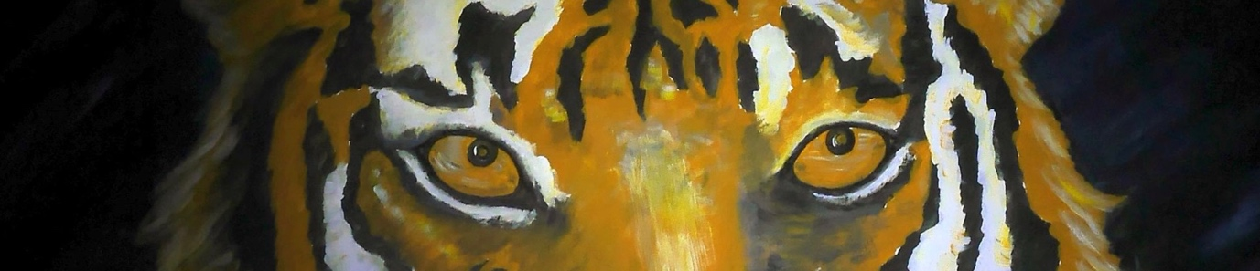

The Tiger GmbH is a specialist manufacturer of crucibles for high temperature applications. We have developed a range of new Zirconia crucibles for melting the platinum group metals (PGM). The crucibles can also be used for melting Nickel and Cobalt super alloys and Uranium. The significant improvement is the longer life of the crucible.

Tiger Zirconia Crucibles give cleaner melts at temperatures up to and above 1900°C – this is due to their slower vitrification rate. Zirconium Oxide is an excellent insulating material and will withstand many multiple melts. The crucibles can be stabilised with Calcium Oxide, Yttrium or Magnesium Oxide. The Zirconia crucible can also be contained within an outer Alumina crucible to further extend the life of the product.

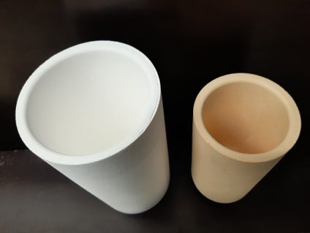
Each crucible is hand made to the highest quality / specification and visually inspected in quality control to give improved performance and reliability in use. This attention to detail in our manufacturing process means that Tiger crucibles give exceptional performance especially when compared to isostatically pressed products.
Alumina and Zirconia Crucible

- Improved life and reliability – some customers have experienced 25 melts
- High temperature resistance up to and above 1900°C
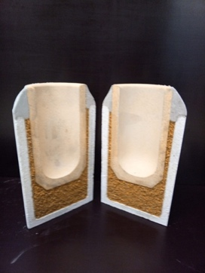
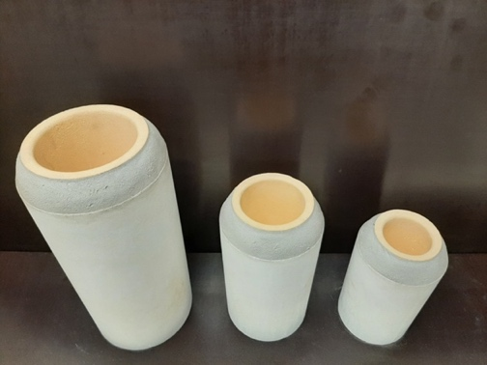
- Cleaner melt due to the slower vitrification gives purer metal and less contamination.

Tiger Zirconia crucibles are used by Platinum Group Metal (PGM) refineries, mining companies, Platinum alloy suppliers, Platinum jewellery factories, Investment casting foundries for medical applications and Specialist foundries using Nickel and Cobalt based super alloys.
ACTUAL CRUCIBLE DIMENSIONS AVAILABLE

Order No | Description | External Diameter mm | External height mm | Internal Diameter mm | Internal height mm
7701.33 | Zirconium Crucible | 42 | 70 | 30 | 60
7702.88 | Alumina Crucible | 64 | 115 | 50 | 105
7703.38 | ZrO₂ / Al₂O₃ Set # 1 | 64 | 115 | 30 | 60
7711.33 | Zirconium Crucible | 56 | 88 | 38 | 78
7712.88 | Alumina Crucible | 86 | 103 | 66 | 93
7713.38 | ZrO₂ / Al₂O₃ Set # 1 | 86 | 103 | 38 | 78
7721.33 | Zirconium Crucible | 70 | 115 | 50 | 105
7722.88 | Alumina Crucible | 100 | 135 | 80 | 125
7723.38 | ZrO₂ / Al₂O₃ Set # 2 | 100 | 135 | 50 | 105
7731.33 | Zirconium Crucible | 80 | 142 | 58 | 128
7732.88 | Alumina Crucible | 110 | 162 | 90 | 155
7733.38 | ZrO₂ / Al₂O₃ Set # 3 | 110 | 162 | 58 | 128
7741.33 | Zirconium Crucible | 98 | 170 | 77 | 155
7742.88 | Alumina Crucible | 128 | 205 | 108 | 195
7743.38 | ZrO₂ / Al₂O₃ Set # 4 | 128 | 205 | 77 | 155
7751.33 | Zirconium Crucible | 122 | 245 | 98 | 232
7752.88 | Alumina Crucible | 150 | 300 | 130 | 290
7753.38 | ZrO₂ / Al₂O₃ Set # 5 | 150 | 300 | 98 | 232
7761.33 | Zirconium Crucible | 150 | 250 | 125 | 230
7762.88 | Alumina Crucible | 196 | 310 | 166 | 295
7763.38 | ZrO₂ / Al₂O₃ Set # 6 | 196 | 310 | 125 | 230

TECHNICAL SPECIFICATIONS
 | ZIRCONIUM OXIDE CRUCIBLE |  | ALUMINA OXIDE CRUCIBLE
Chemical analysis | ZrO₂ 94%  CaO 4.0 %  SiO₂ 0.4 %  Al₂O₃ Trace  Y₂O₃ Trace  Fe₂O₃ Trace |  | Al₂O₃ 98 %  CaO 1.0 %  SiO₂ 0.2 %  Fe₂O₃ 0.1 %  MgO Trace
Thermal Expansion | 6-9.5 x 10¯⁶ |  | ---------
Porosity | ≈ 20.5 % |  | ≈ 23 %
Density | ≈ 4.4 g / cm³ |  | ≈ 3 gm / cm³
Thermal shock | Adequate - the crucible should be back filled and fixed when heated by induction
Max Working temperature | 2000 °C | 1750 °C
Please note that the above information is determined either in our own laboratories and / or in use at our customers. This information is intended as a guide only and no legal rights can be derived.

Please note that we are able to manufacture custom sizes and coatings – simply send us your specification / drawing or sample crucible (can be used).
PLEASE NOTE THAT WE CAN MANUFACTURE ANY SIZE CRUCIBLE – SIMPLY LET US HAVE THE DIMESNIONS REQUIRTED

